Daisy Hollow Farm
Holiday Open House!
830 Daisy Hollow Rd, Dryden, NY 13053
December 5 and 6
December 12 and 13
December 19 and 20
12 pm – 5 pm

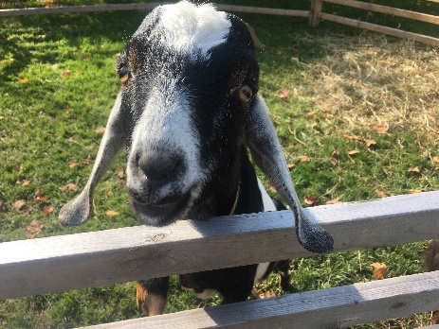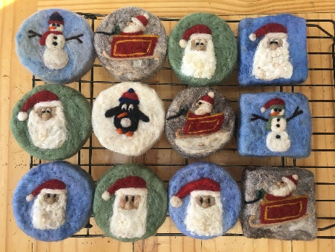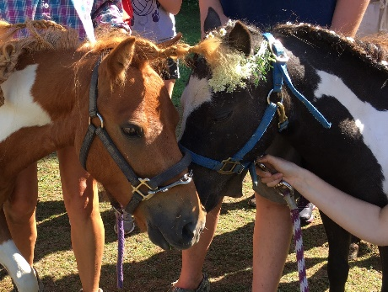

- Holiday Fun – Drink hot cocoa and roast marshmallows over a fire pit!
- Farm Tours – Pet the goats and sheep, play with the pigs, hold the rabbits, give a cow a hug!
- Pony Rides – Weather pending, 1-3 pm each day.
- Farm Fresh Refreshments – Try our delicious yogurt and granola made right here on the farm! Pies by Larry the Pie Guy!
- Visit our Country Store – Handcrafted, all-natural soaps and skin care, felted wool soaps, face masks, hot corn sacks, organic pork and chicken, fresh eggs, granola, maple syrup, honey, beautiful gifts made by local artisans! Store will be opened up, we’ll have tents set up to extend our store space, and a fire in the woodstove! Please wear a mask!

