The following is a list of plants that I personally have tested and found to be highly deer resistant in the deer-overpopulated Cayuga Heights area, Ithaca, NY.
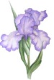
Top Deer Resistant Annuals

- Ageratum houstonianum - Ageratum
- Angelonia spp. – Angelonia
- Antirrhinum majus – Snapdragon
- Begonia semperflorens – Wax Begonia
- Calendula spp. – Marigolds
- Cleome hasslerana – Cleome
- Datura – Thornapple
- Grasses – Annual grasses
- Impatiens - Sunpatiens
- Impatiens hawkeri – New Guinea Impatiens
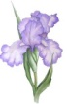
- Limonium tataricum – Statice
- Lobularia maritime – Sweet Alyssum
- Nicotiana sylvestris – Flowering Tobacco
- Senecio cineraria – Dusty Miller
- Verbena spp. – Verbena
- Zinnia spp. - Zinnia

Top Deer Resistant Bulbs
- Allium spp. – Ornamental Onion
- Anemone blanda – Grecian Windflower
- Camassia spp. – Camassia
- Eranthus hyemalis – Winter Aconite
- Eremerus spp. – Foxtail Lily
- Erythronium pagoda – Trout Lily
- Fritallaria spp. – Fritallaria
- Galanthus spp. – Snowdrop
- Hyacinth orientalis – Hyacinth
- Ipheion spp. – Spring Starflower
- Iris spp. – Iris
- Leucojum aestivum – Summer Snowflake
- Narcissus spp. – Daffodil
- Ornithogalum – Star-of-Bethlehem

Top Deer Resistant Perennials

- Achillea millefolium – Yarrow
- Aconitum spp. – Monkshood
- Agastache – Hyssop
- Ajuga spp. – Bugleweed
- Alcea spp. – Hollyhock
- Alchemilla mollis – Lady’s Mantle
- Amsonia spp. – Amsonia ( ‘Blue Star’,‘Blue ice’)
- Aquilegia canadensis – Columbine
- Arabis spp. – Rock Cress
- Arisaema triphylum – Jack-in-the-Pulpit
- Armeria spp. – Thrift
- Artemesia spp. – Wormwood
- Arum italicum – Arum
- Asarum europauem – European Wild Ginger
- Asclepias spp. – Butterfly Weed
- Brunnera spp. – Siberian Bugloss
- Campanula carpatica – ‘Blue Clips’, ‘White Clips’ Bellflower
- Cerastigam plumbaginoides- Plumbago
- Cimicifuga racemosa – Snakeroot
- Cimicifuga simplex - Bugbane
- Crocosmia – Crocosmia
- Dicentra – Bleeding Heart
- Digitalis spp. – Foxglove
- Echinops ritro – Globe Thistle
- Epimedium spp. – Epimedium
- Eupatorium rugosum – Snakeroot
- Euphorbia spp. – Euphorbia
- Ferns – Ghost Fern
- Galium odoratum – Sweet Woodruff
- Geranium macrorhizum – Big Root Geranium
- Geum – Geum
- Grasses – Ornamental Grasses (Variegated Japanese Silver Grass)
- Guara
- Helleborus –Hellebore
- Iris spp. – Iris
- Lavandula spp. – Lavender
- Liatris spicata – Blazing Star
- Ligularia- Ligularia
- Nepeta spp. – Catmint ( ‘Walker’s Low’)
- Pachysandra – Pachysandra
- Perovskia atriplicifolia – Russian Sage
- Phlox subulata – Moss Phlox
- Polygonatum spp. – Solomon’s Seal
- Primula spp. –Primrose
- Pulmonaria spp. – Lungwort
- Salvia spp. – Salvia
- Sedum ‘John Creech’ – John Creech Sedum
- Veronica ‘Georgia Blue’ – Georgia Blue Veronica

Top Deer Resistant Shrubs

- Berberis spp. – Barberry (invasive)
- Buddleia spp. – Butterfly Bush (‘Lo and Behold’)
- Buxus spp. – Boxwood (‘Green Mountain’, ‘Winter Gem’)
- Caryopteris clandonensis – Blue Mist Shrub
- Cotoneaster spp. – Cotoneaster
- Daphne spp. – Daphne
- Deutzia spp. – Deutzia (‘Nikko’, ‘Strawberry Fields’)
- Hypericum spp. – St. Johnswort
- Ilex glabra – Inkberry
- Juniperus spp. – Juniper
- Kolwitzia amabilis – Beautybush
- Leucothoe spp. – Leucothoe
- Microbiota decussata – Siberian Cypress
- Pieris spp. – Andromeda (‘Mountain Fire’)
- Potentilla spp. – Potentilla (‘Abbottswood’, ‘Mango Tango’)
- Rhus aromatica – Fragrant Sumac
- Spirea spp. – Spirea - (‘Goldmound’)
- Stephanandra spp. – Stephanandra
- Syringa spp. – Lilac (‘Bloomerang’)
- Viburnum spp. – Viburnum (‘Newport’, ‘Doublefile’)

Top Deer Resistant Trees
- Acer palmatum – Japanese Maple
- Betula spp. – Birch (River Birch)
- Cercidiphyllum japonica – Katsura
- Cercis Canadensis – Redbud
- Chionanthus spp. – Fringetree
- Magnolia spp. – Magnolia (‘Royal Star’)
- Picea spp. – Spruce (‘Baby Blue Eyes’, Dwarf Alberta)
- Stewartia pseudocamellia - Stewartia
- Syringa reticulata – Japanese Tree Lilac
Notes:
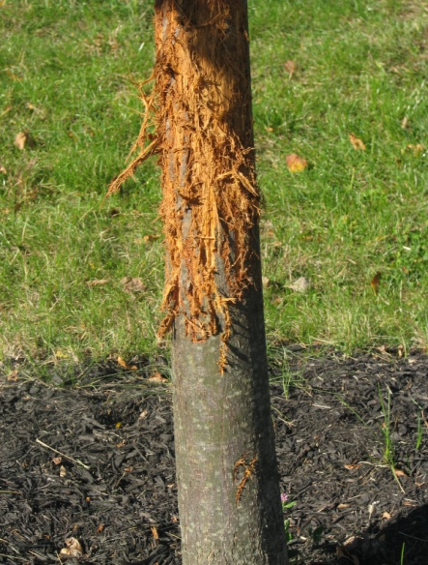
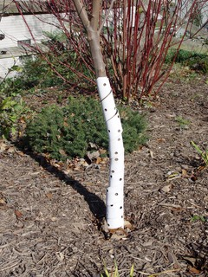
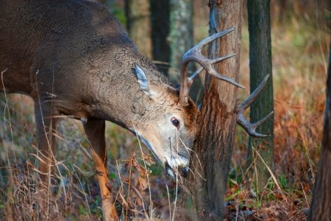
- All saplings should have their trunks protected with tree wrap throughout early fall and winter to protect tender bark from buck rub; wrap should be removed in the spring

- Fawns will try many plants at least once, so if you notice damage to a plant that is seldom bothered by deer, it may have been a fawn “taste-testing”
- Even some of the more deer resistant shrubs and trees may benefit from winter protection from deer in the form of temporary netting

