Daisy Hollow Farm
Holiday Expo
830 Daisy Hollow Rd, Dryden, NY 13053
December 2, 2018
11 am – 5 pm

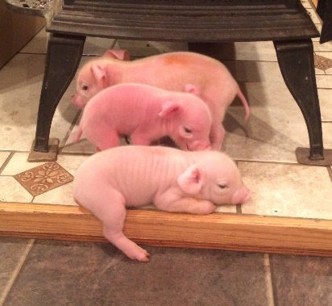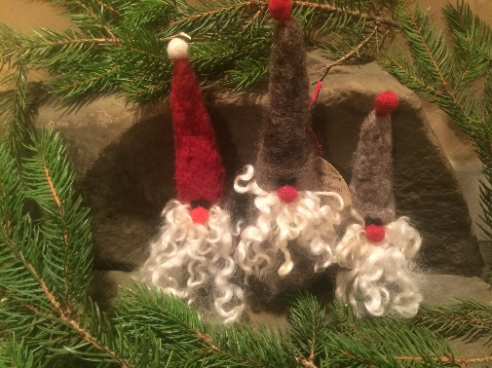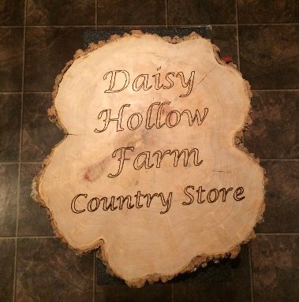

- Farm Tours – Meet the famous piglets, play hide-and-goat-seek, feed the sheep, play with baby bunnies

- Browse our Country Store – Fresh eggs, organic pork, organic chicken, maple syrup, honey, our full product line of all-natural skin care, wool scrubbies, and more!

- Farm Fresh Refreshments – Try the products we make here on the farm: granola, yogurt, maple cookies, jam bars, pulled pork, …!

